GET TO KNOW YOU BINGO
Find someone who…
B | I | N | G | O
Is a student in 1st semester | Is wearing something green | A Domestic Student | Has won an award | Was born in the same month as you
Is a dog owner | Plays a musical instrument | Can speak more than 2 languages | Has never been to the beach | Drinks Coffee
Has been to more than 3 countries | Has a name that starts with the same letter as your name | 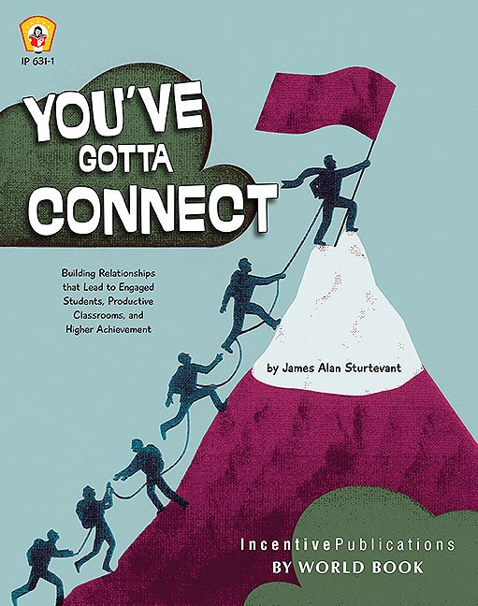 | Is left-handed | Considers winter to be their favourite season
Is enjoying the virtual world | You have never spoken with before | Got a new talent/skill during quarantine | Has a tattoo | Is an only child
Was born in another country than you | Has won a contest | Had vacation plans last year but was hindered by COVID-19 | Loves music | Plays sports
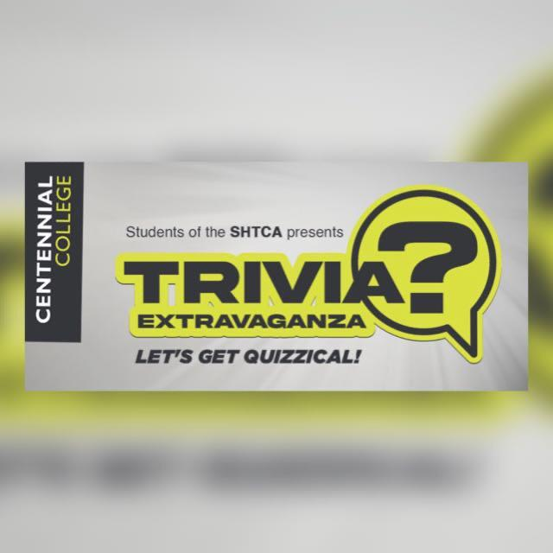

941 Progress Avenue,
Scarborough, ON
M1G 3T8

Phone: 647-572-7884
Email: triviaextravaganza2021@gmail.com
Special Events II
School of Hospitality, Tourism & Culinary Arts
Centennial College

CCCAH

